Outfield (Catchers and 1B working bunts)
Plays at 2B
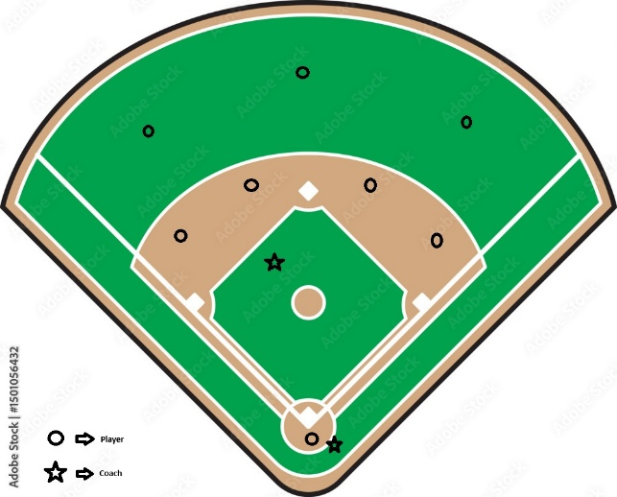
- Fungo LF -> (Cutoff) SS -> 3B
- Fungo CF -> (Cutoff) SS/2B -> 3B
- Fungo RF -> (Cutoff) 2B -> 3B
Plays at 3B
- Fungo LF -> (Cut) SS -> 3B
- Fungo CF-> (Cut) SS -> 3B
- Fungo RF -> (Cut) SS -> 3B
Plays at Home (4)
- Fungo LF -> (Cut) 3B -> C
- Fungo CF -> (Cut) 1B -> C
- Fungo RF -> (Cut) 1B -> C

Infield (OFs take fly balls by another coach)
Plays at (4): Infield in, play at plate
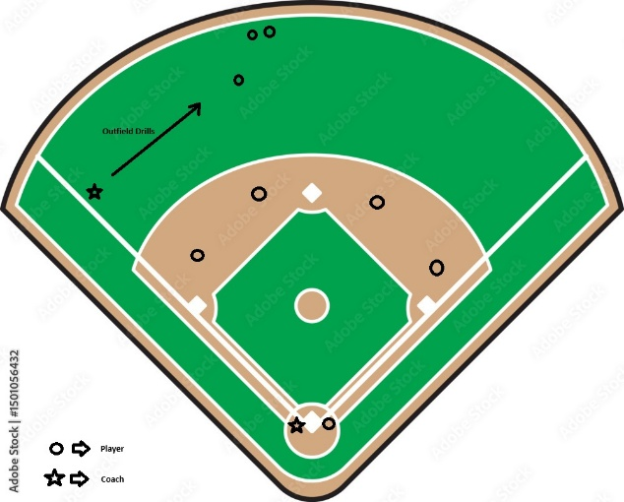
Plays at (1): Infield normal -> 1B
Plays at (2): Double Play Depth
- 3B -> 2B -> 1B (5-4-3)
- SS -> 2B -> 1B (6-4-3)
- 2B -> SS -> 1B (4-6-3)
- 1B -> SS -> 2B (At first) (3-6-4)
  - Or 1B (Tag First) -> SS (Make Tag) -> 3B -> C
- C (Bunt) -> 2B -> 3B -> C
Plays at (4), slow ball to 1B
- 3B -> C, 3B -> 1B
- SS -> C, SS -> 1B
- 2B -> C, 2B -> 1B
- 1B -> C, 1B -> 3B
- C -> Pop Up

